Computer Vision – Week 1

Anh Huy Bui - 293257

1. Homogenous form:
$$x_{1}=\left(2, -1, 1\right)$$

$$x_{2}=\left(1, -2, 1\right)$$

$$x_{3}=\left(1, 1, 1\right)$$

$$x_{4}=\left(-1, 0, 1\right)$$

2. Lines: $$l_{1}=x_{1} x x_{2}=\left(-1*1-(-2)*1, 1*1-2*1, 2*(-2)-1*(-1)\right)=(1, -1, -3)$$
$$l_{2}=x_{3} x x_{4}=\left(1*1-0*1, 1*(-1)-1*1, 1*(0)-1*(-1)\right)=(1, -2, 1)$$

3. Intersection:
5. translation: : 2 Dof
6. euclidean: $\left[\begin{matrix}cos θ & -sin θ & t_{x} \\ sin θ & cos θ & t_{y} \\ 0 & 0 & 1\end{matrix}\right]$: 3 Dof
7. similarity: $\left[\begin{matrix}scos θ & -ssin θ & t_{x} \\ ssin θ & scos θ & t_{y} \\ 0 & 0 & 1\end{matrix}\right]$: 4 Dof
8. affine: $\left[\begin{matrix}a_{11} & a_{12} & t_{x} \\ a_{21} & a_{22} & t_{y} \\ 0 & 0 & 1\end{matrix}\right]$: 6 Dof
9. projective: $\left[\begin{matrix}h_{11} & h_{12} & h_{13} \\ h_{21} & h_{22} & h_{23} \\ h_{31} & h_{32} & h_{33}\end{matrix}\right]$: 8 Dof

Projective has only 8 Dof because the important of this transformation is ratio not the actual value themselves, so this matrix can be changed by multiplication by an arbitrary non-zero scale factor, which make one of the 9 elements result into 1, for example, 1/h33. Therefore, there are only 8 independent ratios among 9 elements.

1. 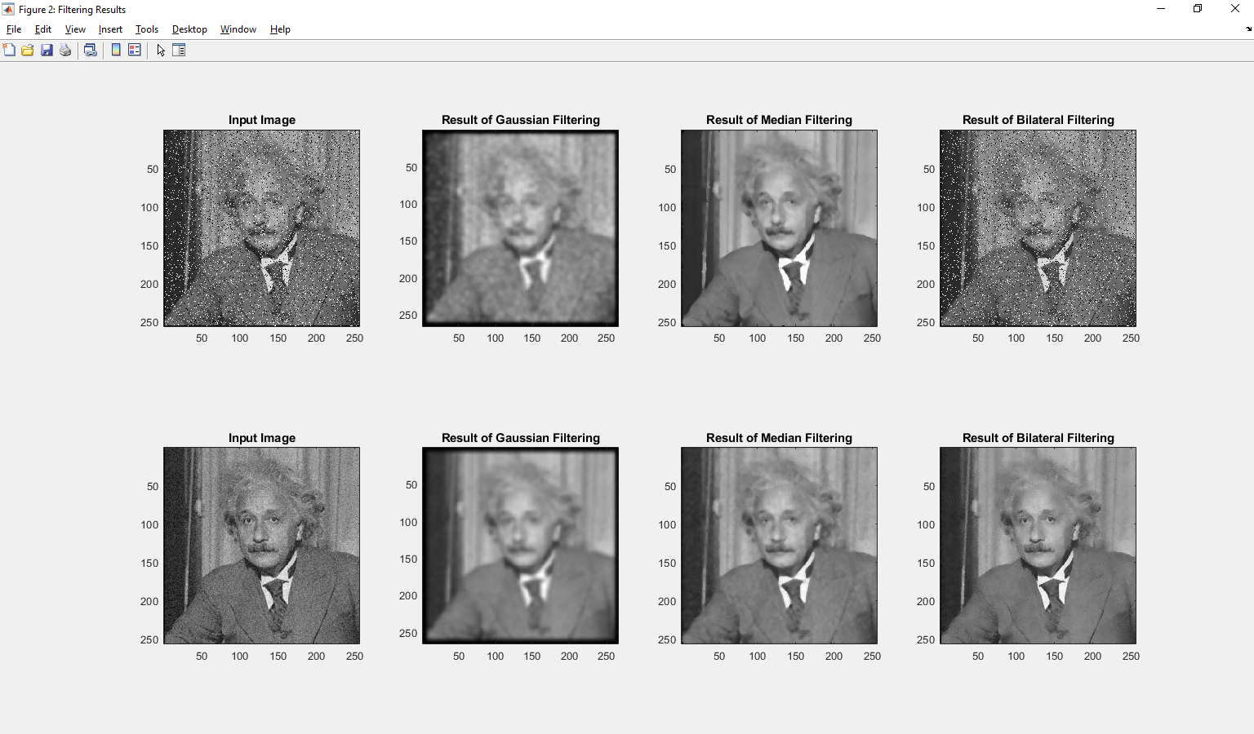
2. Figure 1

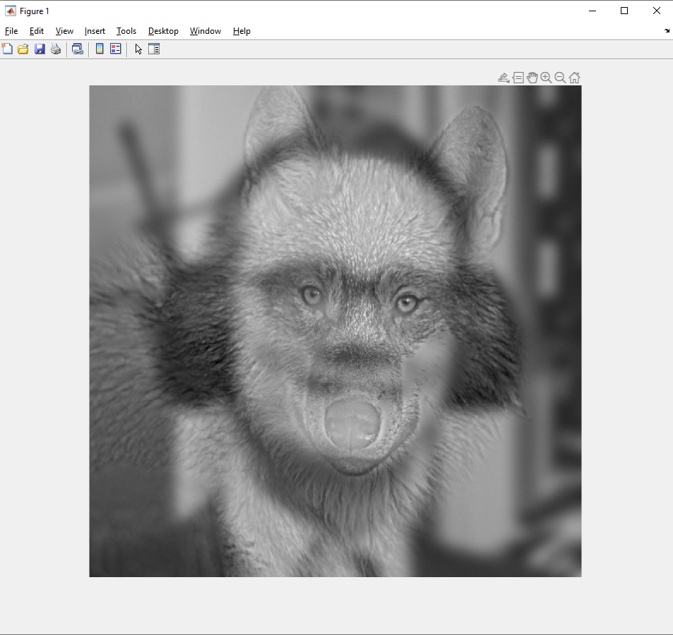

Figure 2

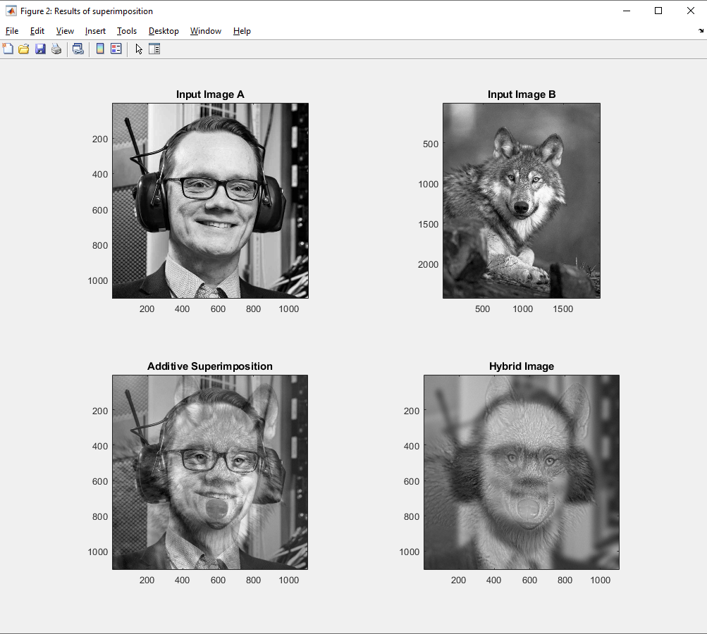

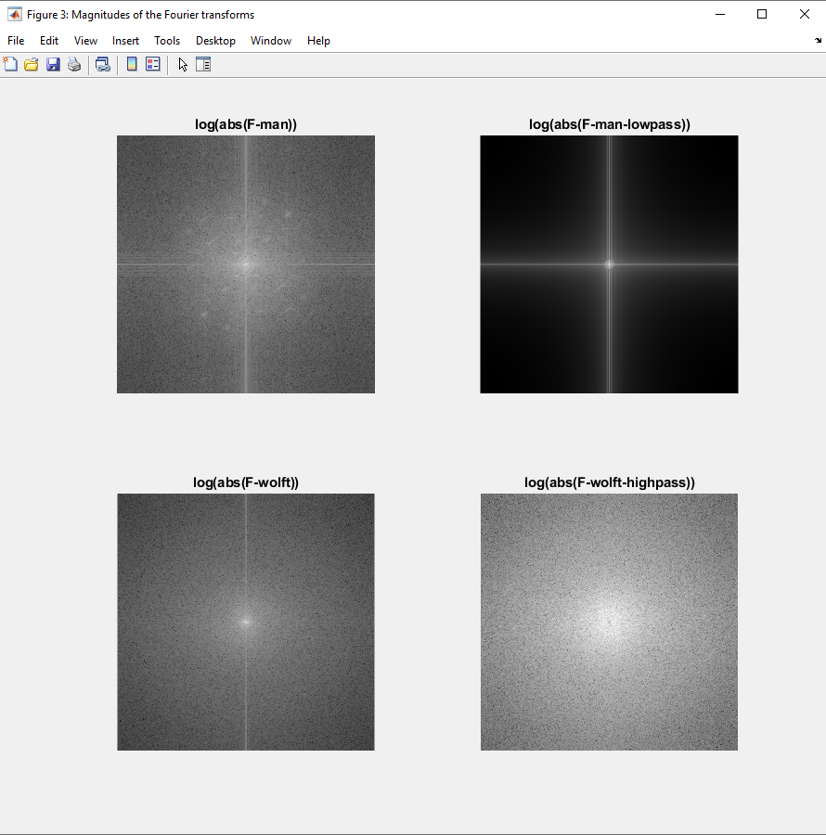Figure 3